**AS 3959 cases**

Comparison of radiative heat flux of AS 3959 method and simulaton.

The radiative heat flux was calculated according to the given method in AS 3959 standard.

During the calculation procedure following parameters were assumed.

* Ambient temperature ($T_{a}$) =308 K (35 0C)
* Relative humidity (RH) = 25%
* Flame emissivity ($ε$) = 0.95
* Flame temperature ($T_{f}$) =1090 K

Basic equations:

1. The radiant heat flux (kW/m2)
2. Flame emissive power

$$E=σεT_{f}^{4}$$

We consider only the flat land (vegetation and site at the same tevel). So $θ=0$ in the caclculation and flame center is over the ground level.

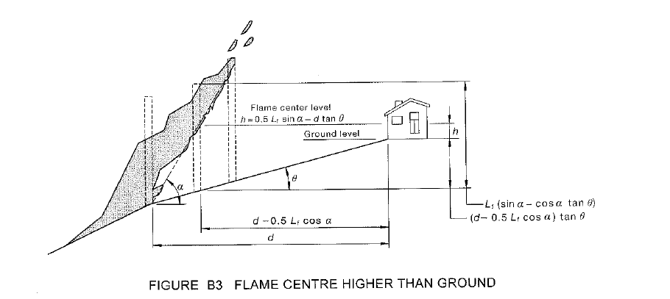

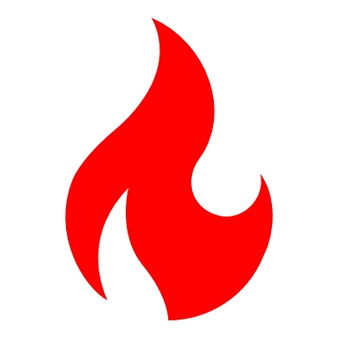

Finding flame angle using the algorithm given in AS 3959 standard (Figure B4, page 10 in 2018 version)

|  |
| --- |
|  |

Alogithm written in python (flameAngle.py)

Correlations

$$∅=f\left(X_{1},X_{2},Y_{1},Y_{2}\right)$$

$$X_{1},X_{2}=f(L_{f},α, θ, h, d)$$

$$Y_{1},Y_{2}=f(W_{f},L_{f},α, d)$$

Therefore $$∅=f\left(L_{f},α, θ, h, d,W_{f}\right)$$

There are different view factors ($∅$) for different distances (d) from vegetation to site. Flame angle was calculated for the $∅_{max}$ of each FDI case.

|  |  |  |  |  |  |
| --- | --- | --- | --- | --- | --- |
| **Case** | **Calculated flame angle ($α^{0}$) by the algorithm given in AS 3959** | | | | |
| **BAL12.5** | **BAL19** | **BAL29** | **BAL40** | **BALFZ** |
| FDI 100 | 71.452 | 69.050 | 63.842 | 55.206 | 36.970 |
| FDI 80 | 73.289 | 71.180 | 65.820 | 56.990 | 35.690 |
| FDI 50 | 76.045 | 73.655 | 67.917 | 59.807 | 34.234 |

Comparison of simulation and calculated radiative heat flux

|  |  |  |  |  |  |
| --- | --- | --- | --- | --- | --- |
|  | **Radiative heat flux (kW/m2)** | | | | |
| **BAL12.5** | **BAL19** | **BAL29** | **BAL40** | **BALFZ** |
| FDI 100 Algorithm | 2.02 | 4.28 | 16.40 | 31.40 | 68.81 |
| FDI 80 Algorithm | 3.92 | 6.12 | 17.31 | 31.29 | 68.81 |
| FDI 50 Algorithm | 4.96 | 9.90 | 19.58 | 30.65 | 68.81 |
| FDI 100 simulation | 4.03 | 7.48 | 16.37 | 29.07 | 79.20 |
| FDI 80 simulation | 3.08 | 4.01 | 7.21 | 14.68 | 27.72 |
| FDI 50 simulation | 2.26 | 3.33 | 6.52 | 10.91 | 26.51 |

|  |
| --- |
|  |

Firebrands flux and Radiative flux

|  |
| --- |
|  |
| Firebrand flux vs Radiative heat flux in different BAL |

Comparison Simulations and FFDI 100, 80,50

1. FFDI 100 with different flame angles

|  |
| --- |
|  |

1. FFDI 80 with different flame angles

|  |
| --- |
|  |

1. FFDI 50 with different flame angles

|  |
| --- |
|  |